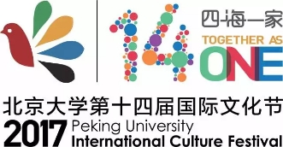
“青年的责任与担当”一带一路青年论坛代表招募
申 请 表
Responsibilities and Commitments of Youth
Peking University “Belt and Road” Youth Forum
Application Form for Delegates
照 片  Photo | 姓名  Name |  |  | 性别  Gender
照 片  Photo | 所在院系  Faculty |  |  | 专业  Major
手机号码  Phone Number |  |  |  | 年级  Grade |  | □本科 （ ）年级  Undergraduate: Grade ( )  □ 研究生 （ ）年级  Graduate: Grade ( )
学习及工作经历
Education and Work Experience
邮箱  E-mail |  |  | 母语  Native Language |  |  |  | 掌握外语及水平  Foreign Language Level

注：请填写申请表后，以附件形式发送至beltandroadyouth@163.com，邮件标题请采用“姓名＋学院＋国籍＋电话号码”。
Ps: After filling in the application, please attach your application in the email and send it to beltandroadyouth@163.com under the subject of "Name+Faculty+Nationality+Phone Number".

